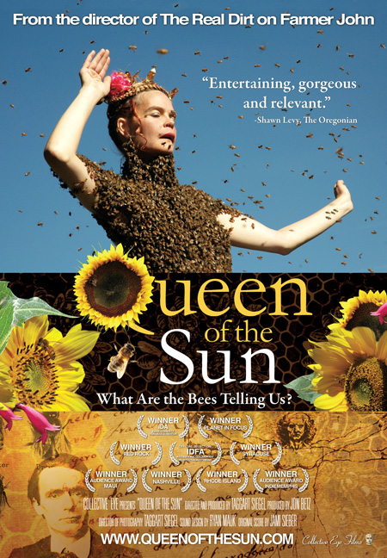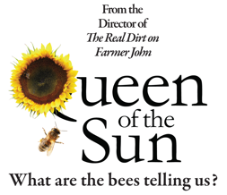

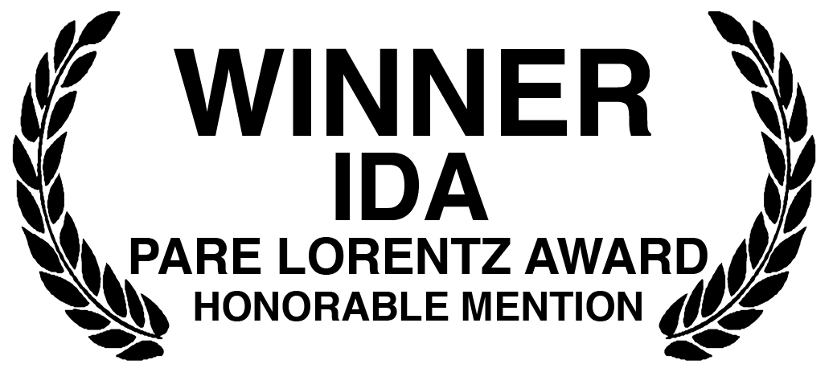

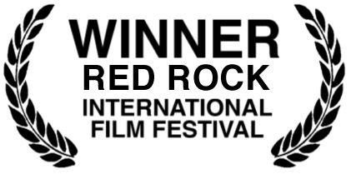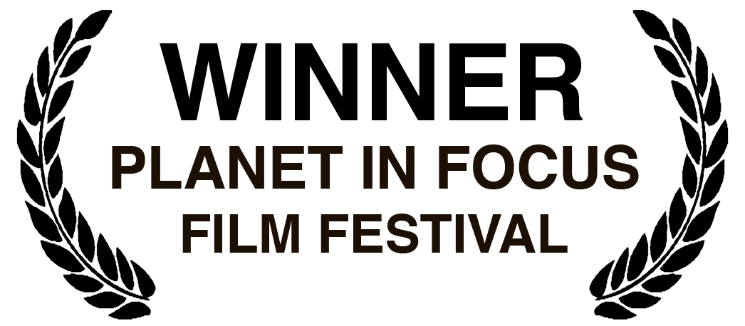

A Collective Eye, Inc. Production | Directed by Taggart Siegel | Produced by Jon Betz

THEATERICALLY RELEASED NATIONWIDE
WINNER OF 10 INTERNATIONAL FILM FESTIVAL AWARDS
NOW ON DVD & DIGITAL

PUBLICITY & THEATRICAL BOOKING CONTACT:
Jon Betz / Collective Eye Films
502-232-5345 / jon@collectiveeye.org

WWW.QUEENOFTHESUN.COM

A COLLECTIVE EYE FILMS RELEASE – WWW.COLLECTIVEEYE.ORG

QUEEN OF THE SUN:
What Are the Bees Telling Us?
A film by Taggart Siegel

SHORT SYNOPSIS

QUEEN OF THE SUN: What Are the Bees Telling Us? is a profound, alternative look at the global bee crisis from the award-winning director of THE REAL DIRT ON FARMER JOHN. Taking us on a journey through the catastrophic disappearance of bees and the mysterious world of the beehive, this alarming and ultimately uplifting film weaves together a dramatic story of the heart-felt struggles of beekeepers, scientists and philosophers around the world. This spellbinding film explores the long-term causes that have led to one of our most urgent global food crises, illuminating the deep link between humans and bees. The story unveils 10,000 years of beekeeping, highlighting how that historic and sacred relationship has been lost. Inspiring and entertaining, QUEEN OF THE SUN uncovers the problems and solutions in renewing a culture in balance with nature.

LONG SYNOPSIS

In 1923, Rudolf Steiner, an Austrian scientist, philosopher and social innovator, predicted that in 80 to 100 years honeybees would collapse. Now, beekeepers around the United States and around the world are reporting an incredible loss of honeybees, a phenomenon deemed “Colony Collapse Disorder.” Bees are disappearing in mass numbers from their hives with no clear single explanation. The queen is there, honey is there, but the bees are gone.
For the first time, in an alarming inquiry into the insights behind Steiner’s prediction QUEEN OF THE SUN: What Are the Bees Telling Us? investigates the long-term causes behind the dire global bee crisis through the eyes of biodynamic beekeepers, commercial beekeepers, scientists and philosophers. QUEEN OF THE SUN features world renowned biodynamic beekeeper Gunther Hauk, New York Times bestselling-author Michael Pollan, Indian Activist Vandana Shiva, and a compelling cast of characters from around the world. Together they take us on a journey through the catastrophic disappearance of bees and into the mysterious world of the beehive. The film unveils 10,000 years of beekeeping, illuminating the deep link between humans and bees and how that historic and sacred relationship has been lost due to highly mechanized industrial practices. Beekeeper Gunther Hauk calls the crisis, “More important even than global warming. We could call it Colony Collapse of the human being too.”
Bees are the engines that keep the earth in bloom. QUEEN OF THE SUN presents the bee crisis as a global wake-up call and illuminates a growing movement of beekeepers, community activists and scientists who are committed to renewing a culture in balance with nature.
OVERVIEW
Queen of The Sun: What Are the Bees Telling Us? is an in-depth investigation to discover the causes and solutions behind Colony Collapse Disorder; a phenomenon where honeybees vanish from their hives, never to return. Queen of The Sun follows the voices and visions of beekeepers, philosophers, and scientists from around the world, all struggling for the survival of the bees. While other bee films focus exclusively on commercial beekeepers, Queen of The Sun emphasizes the biodynamic and organic communities who have differing opinions from many of the outspoken migratory commercial beekeepers and are often overlooked by the media despite their deep and profound insights into the long-term issues that have brought about the recent collapse.
Queen of The Sun reveals bees as a barometer of the health of the world. Bees fly millions of miles to keep the earth in bloom and have provided humans with honey, wax and pollination for our food for over 10,000 years. Through animation and illuminated imagery, Queen of The Sun uncovers how bees were highly revered by the Egyptians, Mayans and Greeks, but the bond between humans and bees, once a sacred partnership is now a complicated, profit-driven, industrial enterprise.
Queen of The Sun draws from the insights of Rudolf Steiner an Austrian scientist who, in 1923, predicted that in 80 to 100 years, bees would disappear. Steiner said: “The mechanization of beekeeping and industrialization will eventually destroy beekeeping.” Gunther Hauk, a main character in the film and a protégé of Steiner’s, against all odds, begins to build the first bee sanctuary in the world. Surrounded by industrial agriculture, he is creating a 600-acre farm to help support the bees in crisis. Through his insights, we are launched into a journey around the world to uncover the compelling perspectives concerning the complex problems bees are facing such as malnutrition, pesticides, genetically modified crops, migratory beekeeping, parasites, pathogens and lack of genetic diversity from over queen breeding. Seeking answers through unique and unusual beekeepers and scientists who have heart-felt respect for their bees we confront and address the harsh realities causing the bees to disappear. Queen of The Sun finds practical solutions and discover the deep link between bees survival and our own.

Queen of The Sun is unique in its approach: while investigating the apocalyptic crisis affecting the bees, it balances the dark reality we face with both the secret wonder of the beehive and the good humor of real, devoted beekeepers. It is neither a dour, nor a dire predictor of gloom. The film weaves the ‘beauty with the beast’: landscapes and beescapes contrast chillingly with the harshness of the Monsanto-dominated global agriculture. The expertise of the scientists and philosophers is clear as they present their cases in an easy-to-digest, unfolding manner, complemented by artful animation and clear compelling imagery.
The characters in Queen of The Sun share a common belief that solutions to the bee crisis lie in a renewal of agriculture and beekeeping that supports the needs of the bee and therefore supports the planet. While their solutions are simple and practical, they are not easy. Queen of The Sun demonstrates their immense efforts to rebuild a community in balance with nature.
Queen of The Sun presents a compassionate inquiry into the struggle of commercial beekeepers who, when faced with skyrocketing demand and staggering losses, do their best with the methods they were taught, often unaware that their standard practices are seriously flawed. For example, artificially bred bees are malnourished on a diet of high-fructose corn-syrup, are confined in plastic hives and are transported thousands of miles, bombarded by exhaust fumes, only to be over-worked in crops soaked in pesticides. A stunning revelation- that to manufacture a single non-organic cotton tee shirt, one third of a pound of pesticide is used- underscores the sheer volume of toxic chemicals commonly being applied to crops. Because of these conditions, the exhausted and weakened pollinators become easy prey for mites, climate change, environmental radiation, viruses, air and water pollution, and the challenging effects of genetically modified crops.

Media amplifies alarm about the worldwide collapse of bee colonies and scientists hunt for a silver bullet cure. In the meantime, bee advocates strive to renew a culture that takes its cues from the hive. They have wisely recognized that the bees, themselves, are our guides and they have looked to the bees’ example of collaboration and community as the model for their own actions. Einstein was right: it is impossible to change any problem by using the same tools that created it. With that in mind, Queen of The Sun highlights non-traditional approaches that do much to create positive global change.

The world is at an opportune moment to see the film. The current possibility for positive change and the universal commitment to saving our planet’s future are linked. Queen of The Sun mirrors the hopefulness of this time of volatile transformation and reassessment. The optimistic response of those who saw The Real Dirt on Farmer John leads us to believe that people are ready to confront the decline of the honeybee population and its dire consequences and to embrace the changes illuminated in the film. It is the positive and hope-laden message of Queen of The Sun that opens its viewers’ minds to the real possibility of a sustainable, healthy and verdant future.

PRAISE FOR QUEEN OF THE SUN

“A remarkable documentary that's also one of the most beautiful nature films I've seen.”
- Roger Ebert, Chicago Sun-Times

“Revelatory! Honey has never looked so delicious. Or so precious.”
- Jeannette Catsoulis, New York Times - Critic’s Pick

 “ The feel-good advocacy movie of the year. ”
- Box Office Magazine
"Vital… Colony collapse disorder might be a lesser-known issue than climate change, but it's one that's arguably more critical."
- Los Angeles Times

“Stunning…as soulful as it is scientific, as uplifting as it is alarming. Siegel sets himself and his film apart with exquisite cinematography and awe-inducing visual artistry.”
-Christine Champ, Film.com

"Entertaining, gorgeous and relevant. Siegel retains the gift of making you dream of making a difference."
-Shawn Levy, The Oregonian

"Visually sumptuous...lovingly shot, near-psychedelic imagery, which serves as an unusually visceral reminder of the rich variety in nature—and what’s at stake if bees bug out for good.
- Village Voice

"Rich, Elegant, Edifying. One of the most beautifully filmed documentaries that I've ever seen."
- Hollywood Report Card
 "Must-see film.. Likely the most important documentary of the year."
- Current

“A real gem … A brilliantly focused film discussing beekeeping throughout the world, and the problems that bees are facing… See it. This film is an important work, and thoroughly enjoyable.”
-Tom Ellis, Filmbalaya
“An inspiring documentary, one of the best films of 2011.”
- Frederic and Mary Ann Brussat, Spirituality and Practice

“Wild, entertaining…You are engulfed by wonder.”
-Michael Van Baker, The Sun Break

“A creative exploration of the global honeybee crisis replete with remarkable nature cinematography, some eccentric characters and yet another powerful argument for organic, sustainable agriculture in balance with nature.”
-Alissa Simon, Variety

 out of 4 “Fascinating new documentary… an irresistible romance about the essential role that honeybees play in maintaining earth's fragile ecosystem. A cautionary tale with a hopeful outlook.”
-Jeff Shannon, The Seattle Times

"A honey of a documentary!”
-Colin Covert, Minneapolis Star-Tribune

"Bee Movie is no B Movie. Whether or not you like honey on your morning muffin, you ought to be concerned with the health of the nation's bees."
-Walter Addiego, San Francisco Chronicle

“Inspiring, humbling, thought provoking, entertaining, and beautifully shot. A call for cultural renewal, for a holistic and compassionate understanding of these amazing creatures. ”
-Rebecca Briggs, Biodynamics Magazine
“Colony Collapse Disorder should be a planetary wake up call akin to Rachel Carson’s 1960s pesticide expose Silent Spring.”
- David Lamble, Bay Area Reporter

“Quite an eye-opener. You’ll think twice before ever swatting another bee.”
- SF Bay Guardian

“Queen of the Sun is hardly the first documentary about the world’s vanishing honeybees but it may well be the best … If we hope to save ourselves and our planet, we first need to be prepared to save the bees.”
-Gar Smith, Berkeley Daily Planet

“Beautifully blends poetry and science to tell the story of what may be the most important co-evolutionary bond on Earth… Queen of the Sun's optimistic tone suggests solutions will flower from the seeds of new perspectives.”
- Rick Marianetti, The Examiner

“Queen of the Sun inspires all to get involved in Earth's ecological future, and gives an optimistic vision of the future of food production.”
-Carly Dahlen, Screenology

“Astonishing…luminous, compelling.” -Jane Sumner, Austin 360

“Queen of the Sun breathes love and hope into the catastrophic crisis inundating our oldest domesticated animal, the honey bee. I was moved from tears to hope as the film gently offered next steps anyone could take to make the world a better place…”
-Barbara Booth, Santa Fe Waldorf School

"A fascinating, emotional look at industrial agriculture and its toll on Mother Nature."
-Seattlest

“I never thought that a documentary about honeybees would make me both laugh and cry-but filmmaker Taggart Siegel’s Queen of the Sun is one such film.”
-Dennis Hartley, Hullabaloo

“Full of moments that inspire that kind of childlike awe of these remarkable insects.”
-Morgan Rush, Alternatives Magazine

ABOUT THE DIRECTOR

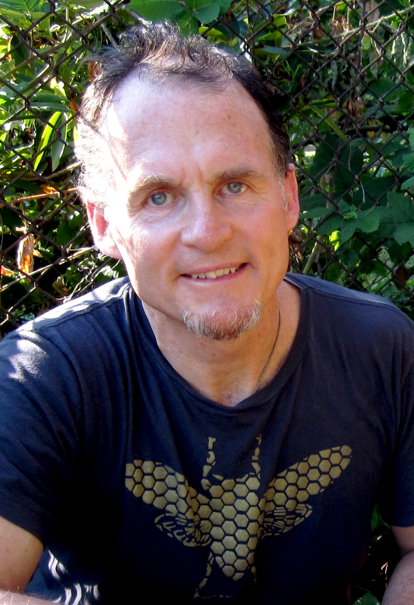
An independent filmmaker since the mid-1980’s, Taggart Siegel is best known as the director of the 2006 grass-roots hit THE REAL DIRT ON FARMER JOHN. This critically acclaimed feature documentary about a maverick visionary farmer, won 31 international film festivals awards and was released theatrically around the world. Siegel is also known for his award-winning films THE SPLIT HORN: Life of a Hmong Shaman in America, BETWEEN TWO WORLDS and BLUE COLLAR AND BUDDHA which capture the struggle of refugees in America. He is the co-founder of Collective Eye, Inc., a non-profit media production and distribution organization based in Portland, Oregon and San Francisco.


PRODUCER/EDITOR: Jon Betz is an independent documentary filmmaker and producer. With director Taggart Siegel, Betz recruited an award-winning production team and spent 3 years producing and releasing the film to an international audience. Betz's other work includes MEMORIZE YOU SAW IT, is an intimate autobiographical documentary journaling his time as an aid worker living with former-child soldiers in Eastern Uganda. Betz has led workshops, taught classes and lectured on documentary filmmaking practice. His films strive to dig deeply into spiritual, emotional and ethical issues and bring pressing social and environmental issues to the screen. Betz is a graduate from Rhode Island School of Design. He is the Director of Collective Eye, Inc. a non-profit media production and distribution organization based in Portland, Oregon.
COMPOSER: Electric cellist and vocalist Jami Sieber reaches inside the soul with compositions that are contemporary, timeless, lush, and powerfully evocative. Her style of performance has been recognized internationally. An innovative musician, Jami's music moves beyond the surface, seeking and re-seeking her truth by creating musical bridges and connections. Jami's life-long commitment to the environment, social justice, and the healing arts is at the heart of her music, reflecting a deep dedication to the arts as a medium of exploration and awareness of the interconnectedness of all beings. Jami has written musical scores for film, theater and dance, possessing an innate ability to use her instrument like a painter, adorning her musical canvas with washes of vivid tones and reflective moods. Jami, at her core, is in a constant state of re-invention which manifests in her music, engaging all of the senses and the depths of the imagination and creating experiences that invite listeners to new realms of perception.
KEY CAST
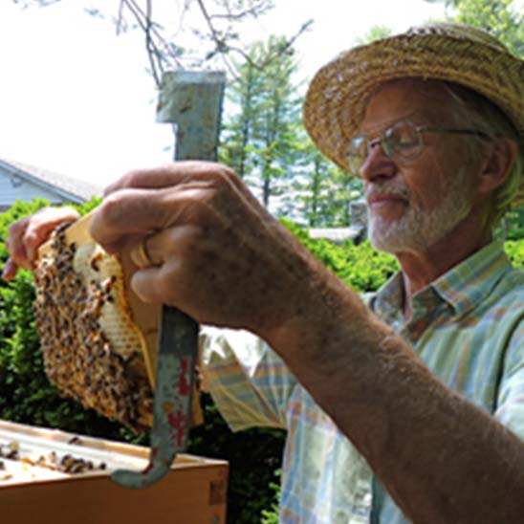
GUNTHER HAUK
Biodynamic Beekeeper & Farmer
Founder Spikenard Farm & Honeybee Sanctuary

Gunther Hauk (The Honeybee Crisis: An Opportunity to Transform Destructive Agricultural Practices and Real Food for Thought and Stomach: An Introduction to Biodynamic Agriculture) is one of the central inspiring figures in Queen of the Sun. Gunther was a Waldorf teacher for 23 years and was co-founder of Spikenard Farm in 2006 and the Pfeiffer Center in 1996. Hauk is the author of Toward Saving the Honeybee (published by the Biodynamic Association). He and his wife Vivian are now located in Floyd, Virginia, where they are building up the honeybee sanctuary in which people can experience the healing of the land, the honeybees, and, ultimately the human being.
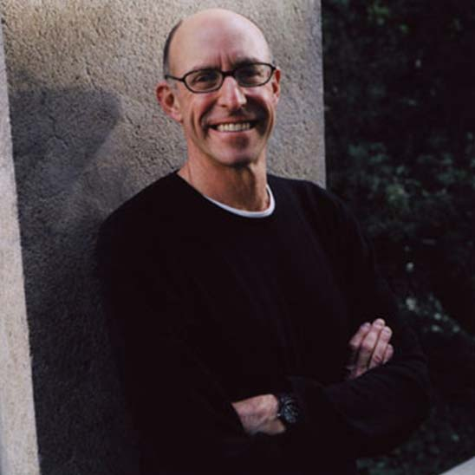
MICHAEL POLLAN
New York Times Bestselling Author
“Omnivore’s Dilemma”

For the past twenty-five years, Michael Pollan has been writing books and articles about the places where nature and culture intersect: on our plates, in our farms and gardens, and in the built environment. He is the author of four New York Times bestsellers. The Omnivore’s Dilemma was named one of the ten best books of 2006 by both the New York Times and the Washington Post. Michael Pollan speaks in Queen of the Sun about the industrialized beekeeping practices in the Central Valley of California and the complex and fascinating evolutionary relationship between bees and flowers.


VANDANA SHIVA
Indian Activist & Physicist

“Vandana Shiva has devoted her life to fighting for the rights of the ordinary people of India … her fierce intellect and her disarmingly friendly, accessible manner have made her a valuable advocate for people all over the developing world.” — Ms. Magazine. In Queen of The Sun, Dr. Shiva speaks about development of chemical agriculture and the effects of pesticides and genetically modified food on bees.

OTHER KEY CAST

RAJ PATEL
Author “Stuffed and Starved”

CARLO PETRINI
President, Slow Food International

HORST KORNBERGER
Philosopher

JEFFREY SMITH
Author “Seeds of Deception”

MAY BERENBAUM
Entomologist

SCOTT BLACK
Biologist, Xerces Society

QUEEN OF THE SUN:
What Are the Bees Telling Us?

A Collective Eye Production

DIRECTED & PRODUCED BY
Taggart Siegel

PRODUCED BY
Jon Betz

ASSOCIATE PRODUCERS
Donald Siegel Eric Stolberg
George Mitchell Mike Quinn

EDITOR  Jon Betz / Taggart Siegel  ORIGINAL SCORE  Jami Sieber  SOUND DESIGN  Ryan Mauk | ANIMATION  Noah Dorsey  Alyssa Timon  Chris Rodgers  Michelle Hwang  Emma Tripp  CINEMATOGRAPHY  Taggart Siegel

TECHNICAL SPECIFICATIONS:

82 minutes • HD / Color • English • 5.1 Dolby Surround Sound, Stereo
This film is not yet MPAA rated.

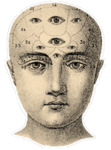


2305 S.E. Yamhill St. Suite #101
Portland, OR 97214
503 232-5345 / 503 295-5515
queenofthesun@collectiveeye.org
http://www.queenofthesun.com
http://www.collectiveeye.org

